Subscriptions

- Legacy pipeline covering a ot of models
- 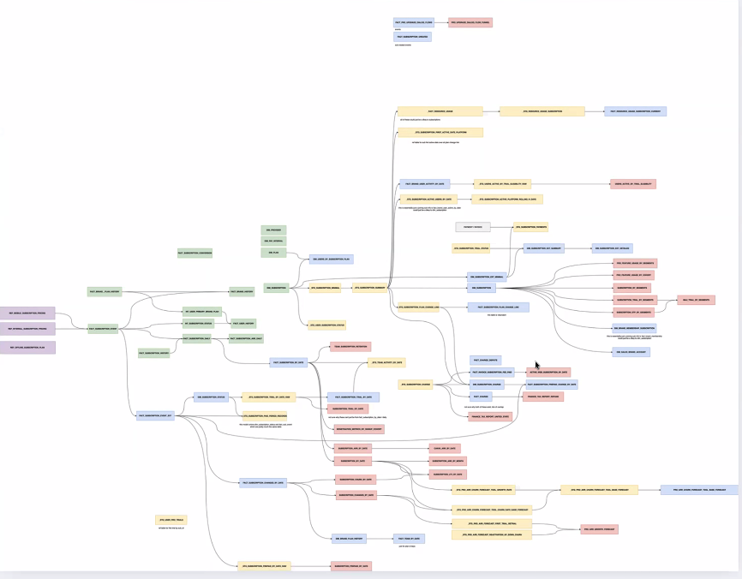
- Create three new layers the the conformed layer, the metrics layer, and the semantic layer.
  - Conformed Layer - Reusable event-level facts and entity models
  - Metrics Layer - Star schema dimensional models
  - Semantic Layer - Governed AI-ready interface via Snowflake Intelligence
- 111 dbt models exist in current state
- A lot of overlap in these models
- A lot of the tables above are duplicated
- How many end consumer tables?
  - DS_PROD tables are the ones owned
  - Around 30 end user tables
  - Around 250 DBT models are used, these need to be redesigned and re-built in a new world order
- DBT complexity:
  - 70% simple
  - 30% complex
- Orchestration
  - Airflow
- Upstream dependencies:
  - Foundation
  - Billing
  - Profile
  - Analytics events (not sure of domain name)
  - Not migrating any upstream dependencies
- Governance
  - No masking in current state
  - At this point, it’s still open
  - But might be subject to change in next months
- Data Migration
  - All source data is available to rebuild historical data
  - Hence, no data migration is required
- Create semantic views in the semantic layer
  - Knows key metrics
  - Clear view of dimensions
  - Mostly around revenue by country, plans
  - Questions around subscription lifecycle
  - Churn, conversion rates
  - 7 semantic views answering close to 50 questions
- Documentation:
  - Provide the solution design document of the migrated DBT project and data model and the new objects created.
  - Handover sessions + KT
- Note: he’s not sure if his own tables are actually used. Mazen will check if some of his tables haven’t been used for the past year and we may be able to remove it from scope
- DS_PROD.REPORT.TEAM_SUBSCRIPTION_RETENTION
  - Not in your list of past 90 days

